1. Installed Elastic search 6.6 / 7.1 and run elasticsearch.bat
2. Open url <http://localhost:9200/> in browser
   1. {
   2. "name" : "LAPTOP-0DTRRONF",
   3. "cluster_name" : "elasticsearch",
   4. "cluster_uuid" : "FWfwTxw9Sf-oGzSW_QzSNQ",
   5. "version" : {
   6. "number" : "7.1.0",
   7. "build_flavor" : "default",
   8. "build_type" : "zip",
   9. "build_hash" : "606a173",
   10. "build_date" : "2019-05-16T00:43:15.323135Z",
   11. "build_snapshot" : false,
   12. "lucene_version" : "8.0.0",
   13. "minimum_wire_compatibility_version" : "6.8.0",
   14. "minimum_index_compatibility_version" : "6.0.0-beta1"
   15. },
   16. "tagline" : "You Know, for Search"
   17. }
3. installed Kibanaka 6.6 and run kibana.bat file
4. open url in browser <http://localhost:5601/app/kibana#/dev_tools/console?_g=()>

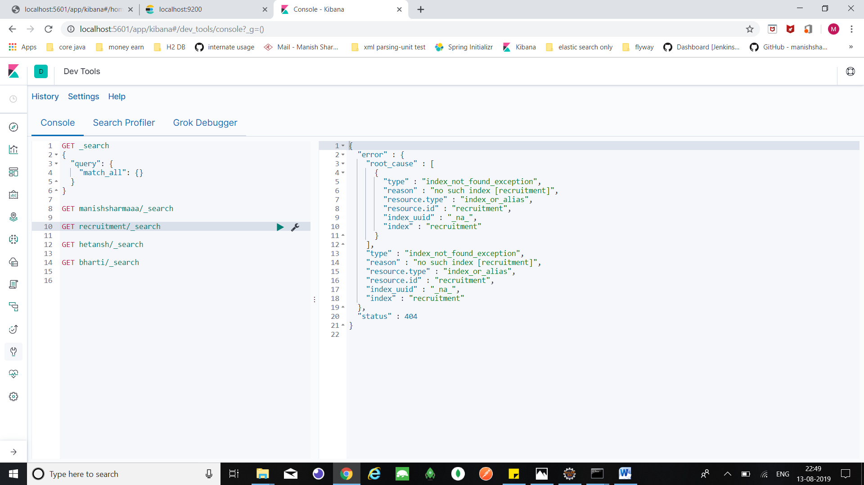

1. open eclipse make spring project with only **web** and add maven elastic 6.6 , in

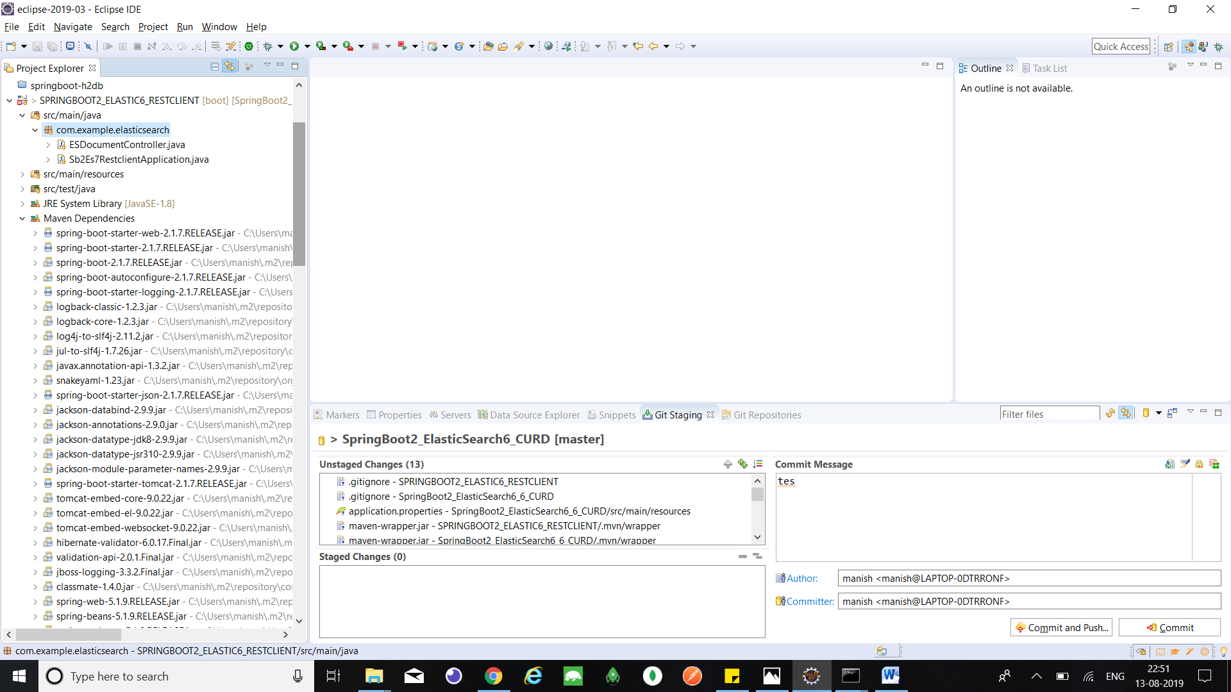

1. Porm.xml

<dependencies>

<dependency>

<groupId>org.springframework.boot</groupId>

<artifactId>spring-boot-starter-web</artifactId>

</dependency>

<dependency>

<groupId>org.springframework.boot</groupId>

<artifactId>spring-boot-starter-test</artifactId>

<scope>test</scope>

</dependency>

<dependency>

<groupId>org.elasticsearch</groupId>

<artifactId>elasticsearch</artifactId>

</dependency>

<dependency>

<groupId>org.elasticsearch.client</groupId>

<artifactId>transport</artifactId>

</dependency>

<dependency>

<groupId>org.apache.logging.log4j</groupId>

<artifactId>log4j-api</artifactId>

</dependency>

<dependency>

<groupId>org.apache.logging.log4j</groupId>

<artifactId>log4j-core</artifactId>

</dependency>

<dependency>

<groupId>org.apache.logging.log4j</groupId>

<artifactId>log4j-web</artifactId>

</dependency>

<dependency>

<groupId>org.json</groupId>

<artifactId>json</artifactId>

</dependency>

</dependencies>

1. Add below methods In Java::

@RequestMapping("/insert")

**public** String insert() **throws** Exception {

@SuppressWarnings("resource")

Client client = **new** PreBuiltTransportClient(Settings.*builder*().put("client.transport.sniff", **true**).put("cluster.name", "elasticsearch").build()).addTransportAddress(**new** TransportAddress(InetAddress.*getByName*("localhost"), 9300));

String jsonObject = "{\"age\":40,\"dateOfBirth\":1471466076564," + "\"fullName\":\"Manish sharma123\"}";

IndexResponse response = client.prepareIndex("manishsharmaaa", "Sharma").setSource(jsonObject, XContentType.***JSON***).get();

**return** response.getResult().toString();

}

1. Start spring service
2. Open below url in POSTMAN

url : <http://localhost:8080/rest/users/insert>

method: post

1. Open kibana url (point 5) and check data using index

Command :

GET <index name>/_search



1. Change application.property

elasticsearch.host=localhost

elasticsearch.port=9200